**SPH3U Unit 5: Electricity and Magnetism**

**Unit Goal:** Circuits, motors, and transformers

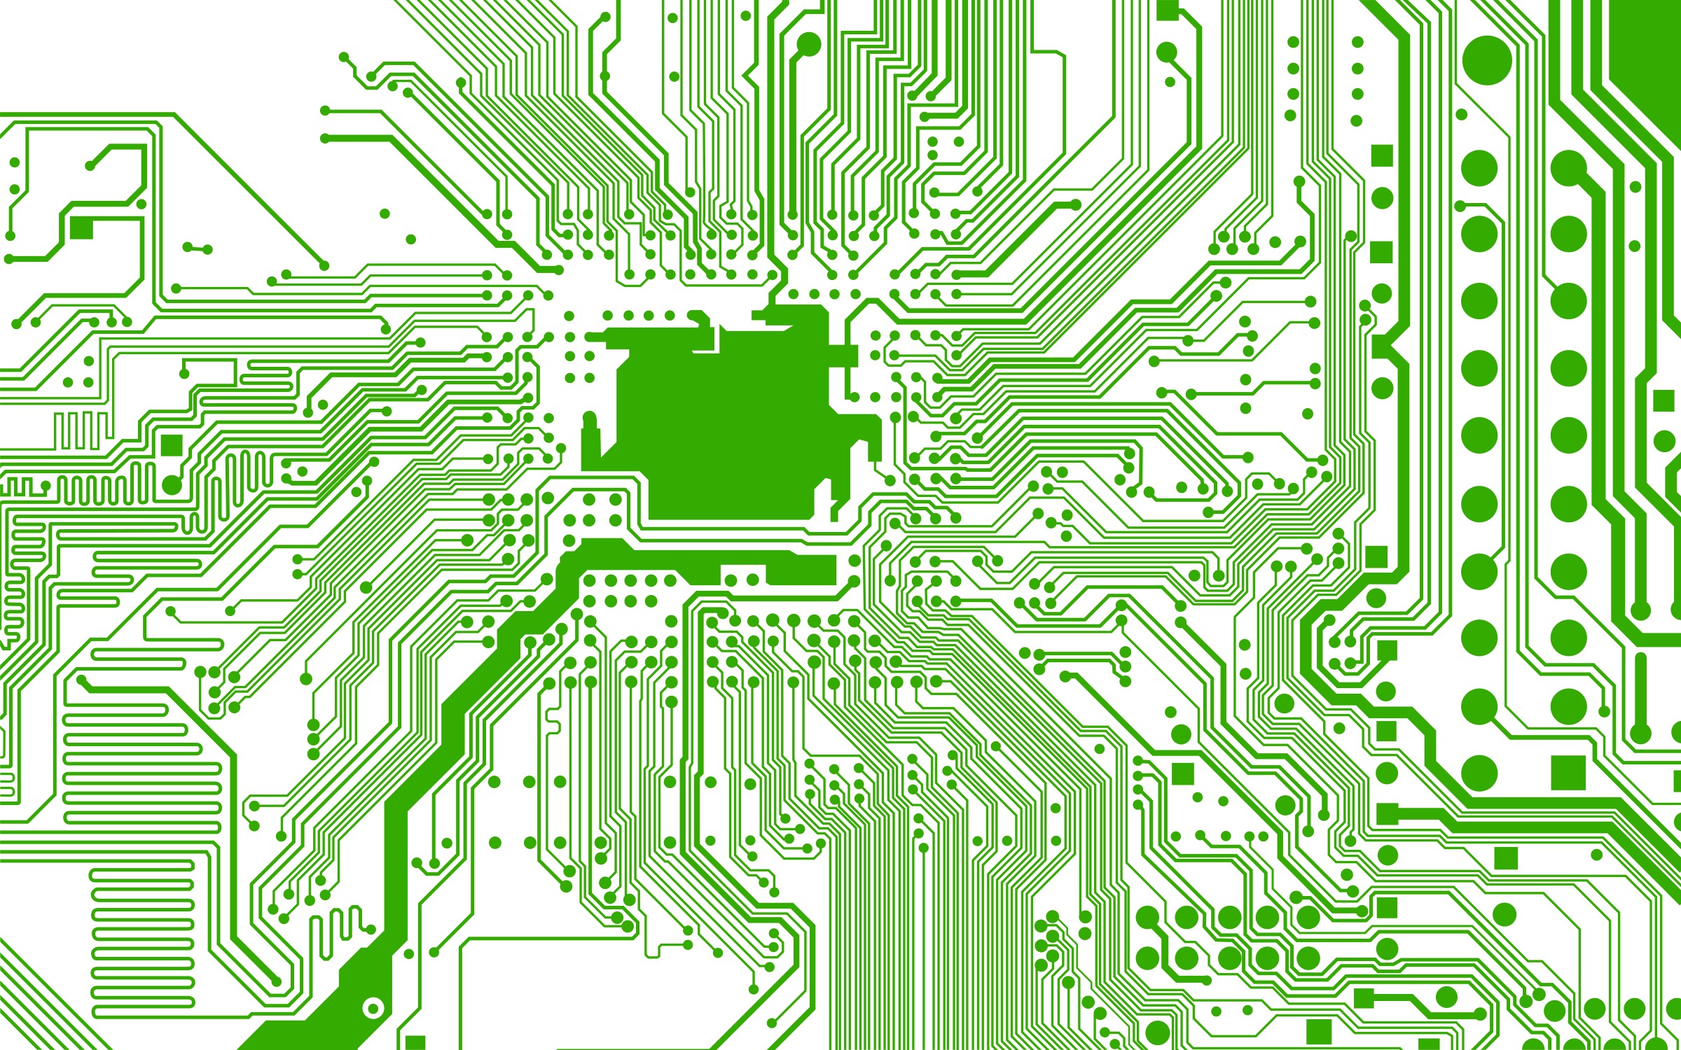 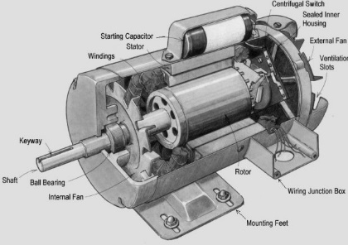 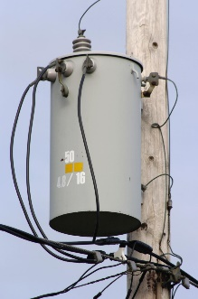

|  |  |
| --- | --- |
| What it is: |  |
| What we want to do: |  |
| What we already know: |  |
| What we need to learn: |  |